Hardware Setup

# Basic Modules

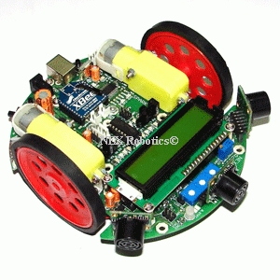

### Spark-V

Spark V robot is based on ATMEGA16A microcontroller. Robot comes with rechargeable 7.2V 600mA NiMH Battery and onboard intelligent battery charger. Robot has onboard socket for Zigbee wireless module for multi robot and robot to PC communication.

### Kinect

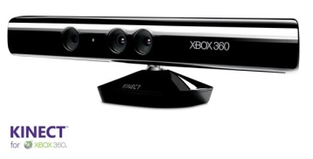Kinect is a motion sensing input device by microsoft for the Xobx 360 video game console and Windows PCs. Based around a webcam-style add-on peripheral for the Xbox 360 console, it enables users to control and interact with the Xbox 360 without the need to touch a game controller, through a natural user interface using gestures and spoken commands.

### XB24-ACI-001.jpgTwo Zigbee Modules

Zigbee is a wireless technolgy which address the unique needs of low-cost, low-power wireless M2M networks. One zigbee is placed on the bot whereas other is connected to pc through a USB cable.

### 2-4g-wireless-camera-803t.jpgWireless Camera, Receiver and TV Tuner

Wireless camera transmit the analog signals which is received by the receiver and TV tuner sends television signals to PC. This video can be received by setting this as video object source in C#.